Mission 4 Assignment Log | Name:
Pre-Mission Preparation
What do you already know about RGB colors?
Many devices use RGB colors for their displays. List some devices:
Mission 4 Checks
Objective #1
What is the code to set the first NeoPixel in the ring to red?

What is the code to set the last NeoPixel in the ring to blue?
Objective #2
How is a tuple like a list? How are they different?

Objective #3
Write two lines of code that:
- Define a constant for a color
- Assign the color to the fifth pixel
Objective #4  Given this code, identify the parts:  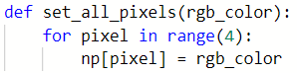 | parameter  # of loops  Loop variable  Index variable
Objective #5
Write a line of code that generates a random number between 1 and 15:
Objective #6
What is the value of a microswitch when it is not pressed?

Explain what this code does:
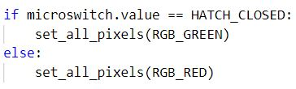
Objective #7
Explain what this code does:
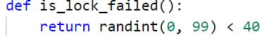

Objective #8
What is the variable “was_pressed” used for?

Post-Mission Reflection
What is a challenge you had with this mission? How did you overcome the challenge?
What is something you learned about yourself during this mission?

